SQOOP Assignment:

1. SERVER connection will be done through the below command.

Sudo service mysqld start



Show databases will show the available databases:

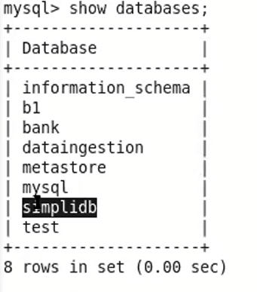

Create a table using create table syntax:

Create table table name;

After that use show stables to see the table.

Then insert values inside it using

Insert into tablename values();

After creating the table we will be able to import the table to our local hadoop using the below command.

Sqoop import –connect jdbc:mysql://localhost/simplidb –table employee –username root –p –target-dir/sqooupout –m 1

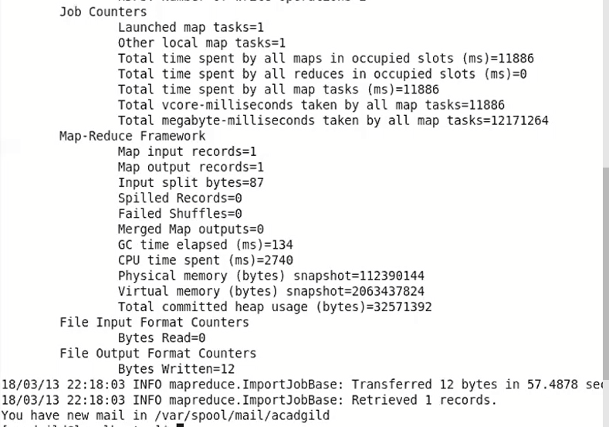

The above command will create a sqoopout folder in hadoop .

Use unix command fs-cat to see the file

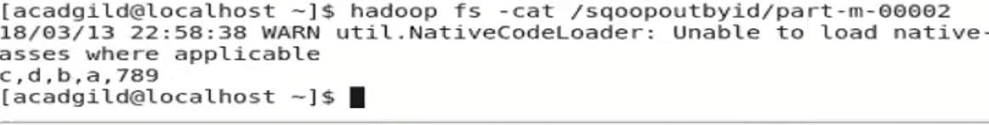

And also we can split using the below command:

Sqoop import –connect jdbc:mysql://localhost/simplidb –table employee –username root –p –target-dir/sqooupoutbyid –m 2 –splitby person_id – 3;